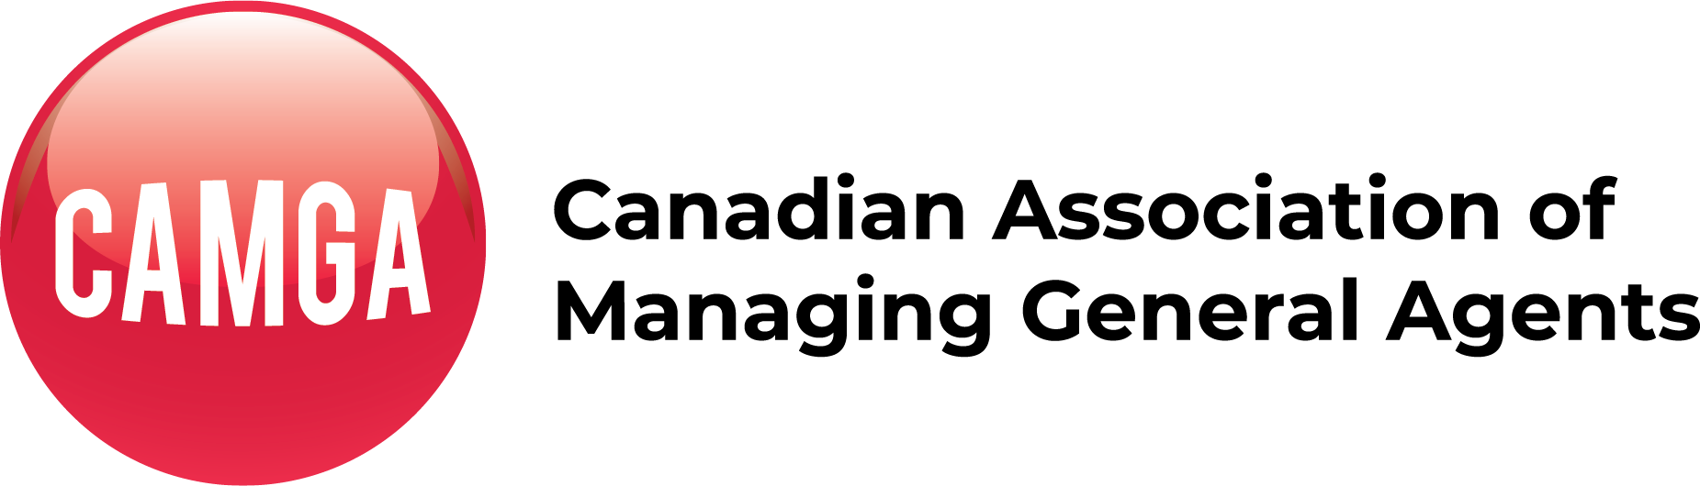

TORONTO – November 16, 2021 The Canadian Association of Managing General Agents (CAMGA) today unveiled a regulatory standard setting regime that will codify minimum business operating elements that MGAs in Canada are required to meet.

“With the voluntary adoption of this undertaking by our members, the brokerages and insurers that we deal with can be assured that these basic best practices are adopted and adhered to by our member MGAs ”, said Steve Masnyk, Managing Director of CAMGA. Masnyk went on to say “There has been too much noise in the industry in regards to the absence of standard operating procedures and transparency as it relates to MGA’s and this will go a long way to address those concerns”.

The standards announced today a) ensure that premium monies are managed responsibly, b) mandate MGAs meet and exceed professional indemnity coverages and c) provide explicit transparency on the carriers that support their underwriting activities. These three pillars will provide assurances to those we deal with of robust protections surrounding the delegated underwriting process.

“These standards are in addition to the strict oversight brought by our carrier partners in the underwriting services we provide.” added MaryKate Townsend, President of CAMGA. “the broker and carrier partners we trade with will now be aware of the standards CAMGA member MGAs follow and be confident that this framework adds even more professionalism into the underwriting activities of MGAs .” added Townsend.

----------------------------------
UNDERTAKING
-To agree to be licensed as an insurance intermediary in those jurisdictions that mandate it
-To carry errors & omissions insurance that meets or exceeds the mandated minimum standards in every jurisdiction in which the member carries on business, as applicable to insurance intermediaries
-To carry a fidelity bond in those jurisdictions where it is mandated
-To maintain a properly constituted trust account for the deposit of insurance premiums received from any source in those jurisdictions where it is mandated
-To ensure that the MGA obtains from the broker/agent a copy of the required Consent & Acknowledgement of Risk Form for all insurance placed with a non-licensed carrier signed by the consumer prior to binding the risk.
-To endeavour to notify the broker of all non-renewals a minimum of forty-five (45) days prior to the renewal date
-To explicitly inform the broker at the quoting stage of the carrier(s) relied upon for the quote
-To notify CAMGA within thirty (30) days of the breach of any of the foregoing undertakings in every jurisdiction in which the member carries on business
For further information please contact:
Steve Masnyk, Managing Director
steve.masnyk@camga.ca
416-903-0478

